School Based Assessment

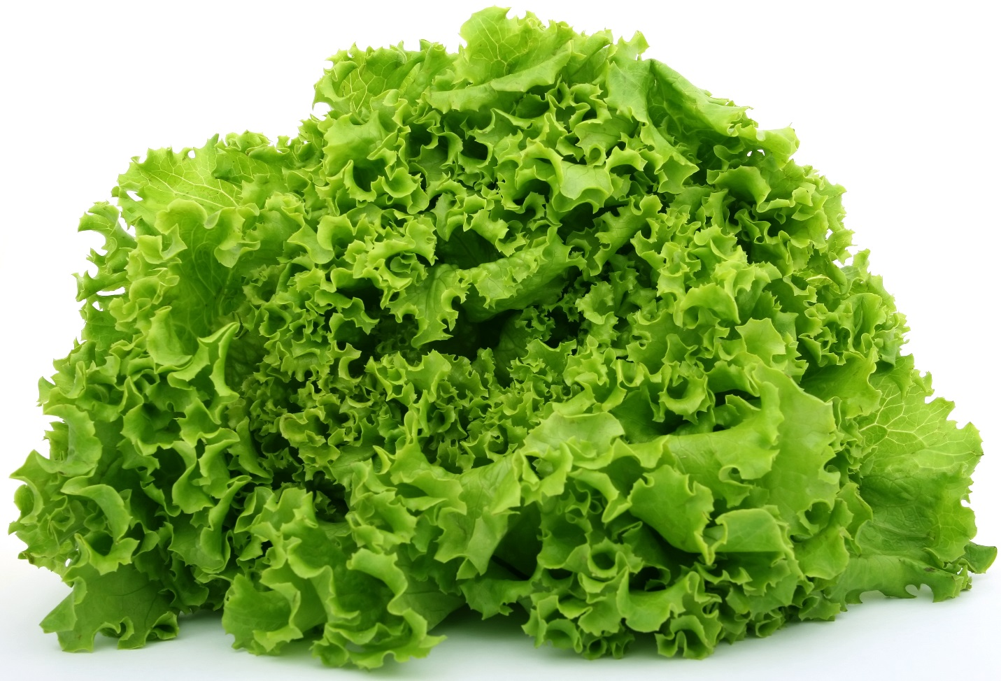

Name of candidate: Sonny Simon Kothapally

Candidate Number : ­­0 9 0 0 1 3 0 4 0 7

Centre Number : 0 9 0 0 1 3

Territory : Guyana

Subject : Agricultural Science

Teacher : Ms. S. Clarke